Full name: Vo Thanh Loc

Staff ID: SD5261

Github:

* [vothanhloc20/sd5261_msa (github.com)](https://github.com/vothanhloc20/sd5261_msa)
* [vothanhloc20/sd5261_azure_infrastructure (github.com)](https://github.com/vothanhloc20/sd5261_azure_infrastructure)

**Use Azure:**

* Create a Virtual machine (OS: Linux (ubuntu 22.04)

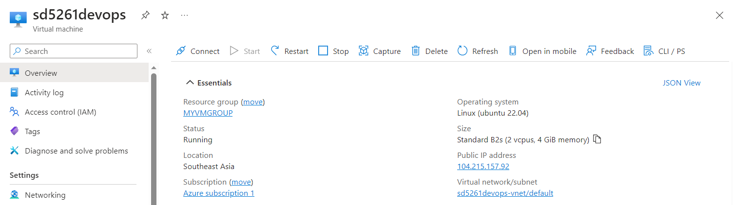

* Install [Docker](https://docs.docker.com/engine/install/ubuntu/), [Jenkins](https://phoenixnap.com/kb/install-jenkins-ubuntu) and [Kubectl](https://kubernetes.io/docs/tasks/tools/install-kubectl-linux/) on Virtual machine

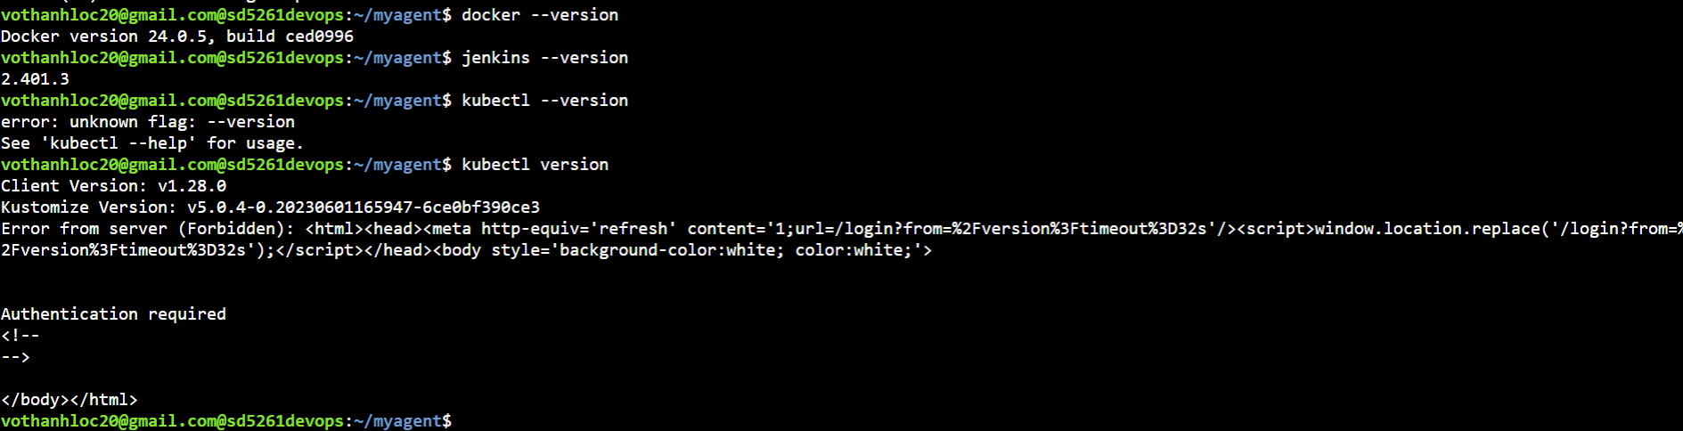

* Apply terraform ([Build infrastructure | Terraform | HashiCorp Developer)](https://developer.hashicorp.com/terraform/tutorials/azure-get-started/azure-build):
  + Source: I depend on this document <https://learn.microsoft.com/en-us/azure/developer/terraform/>
  + Run: *terraform init, terraform plan and terraform apply*

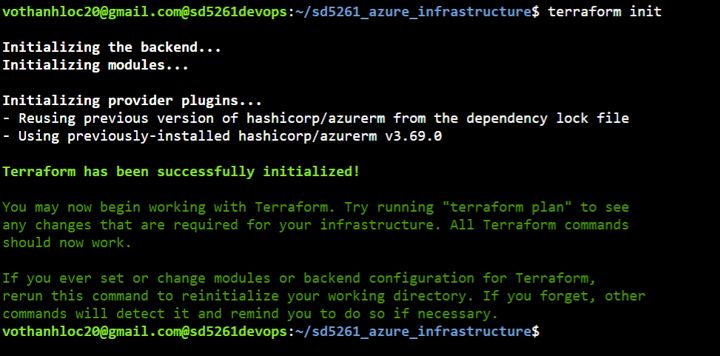  
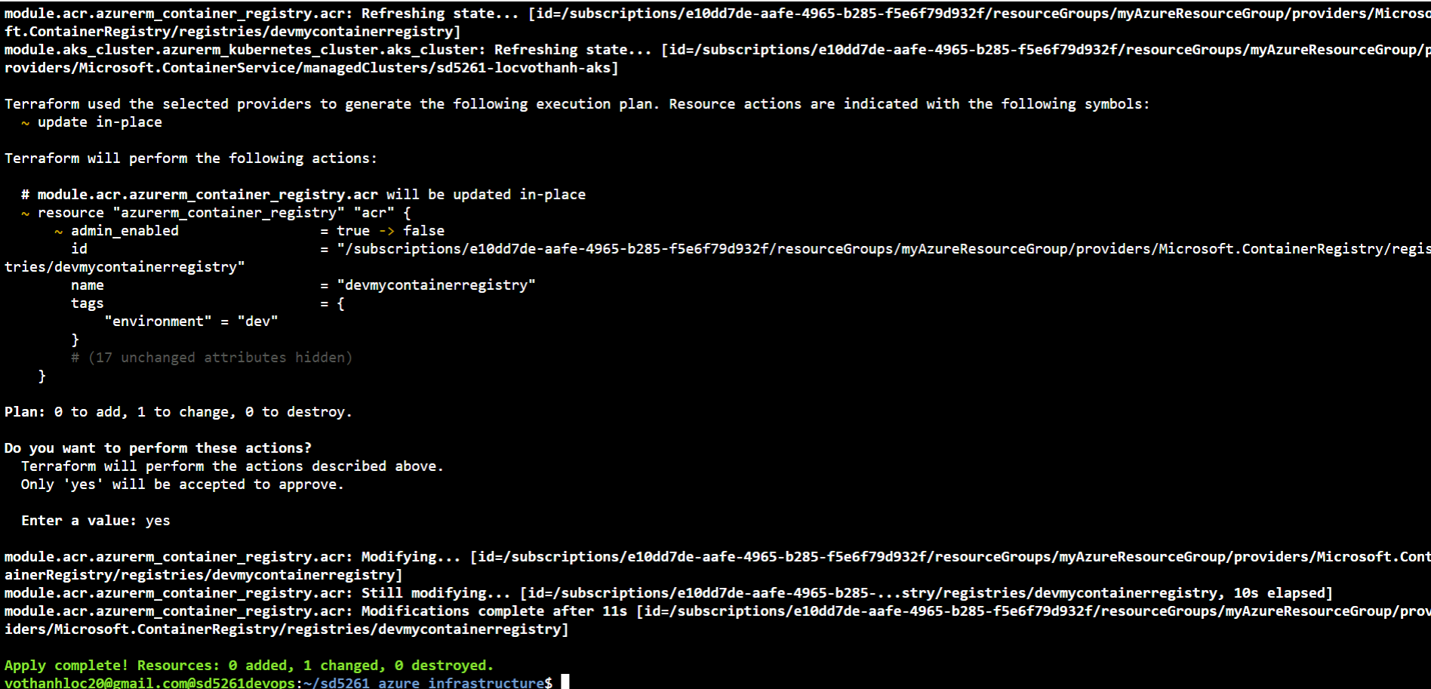

* Then login into Jenkins, use Jenkins for backend, setup Credentials and Backend Pipeline in Jenkins

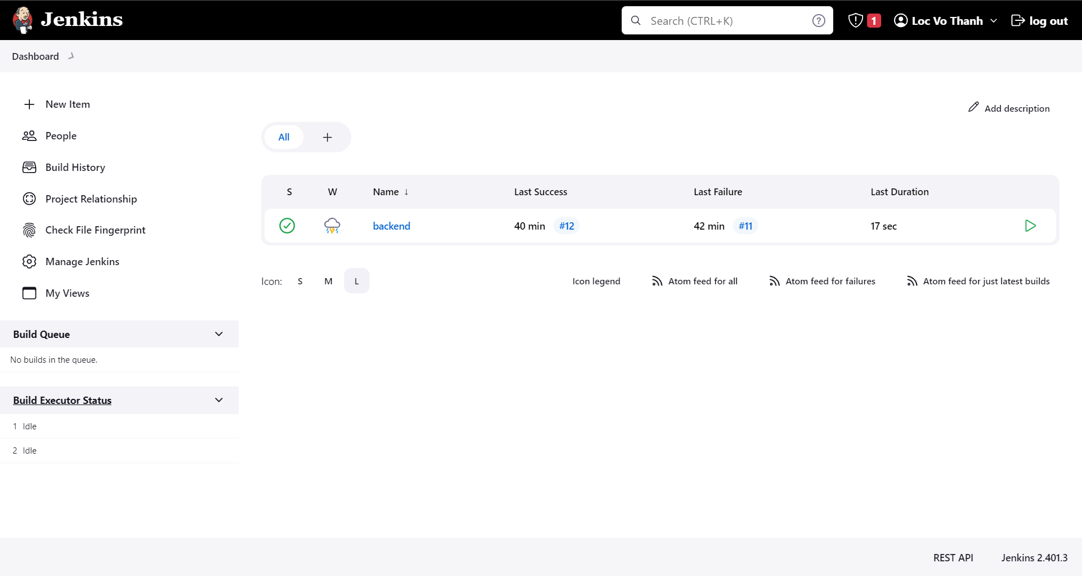  
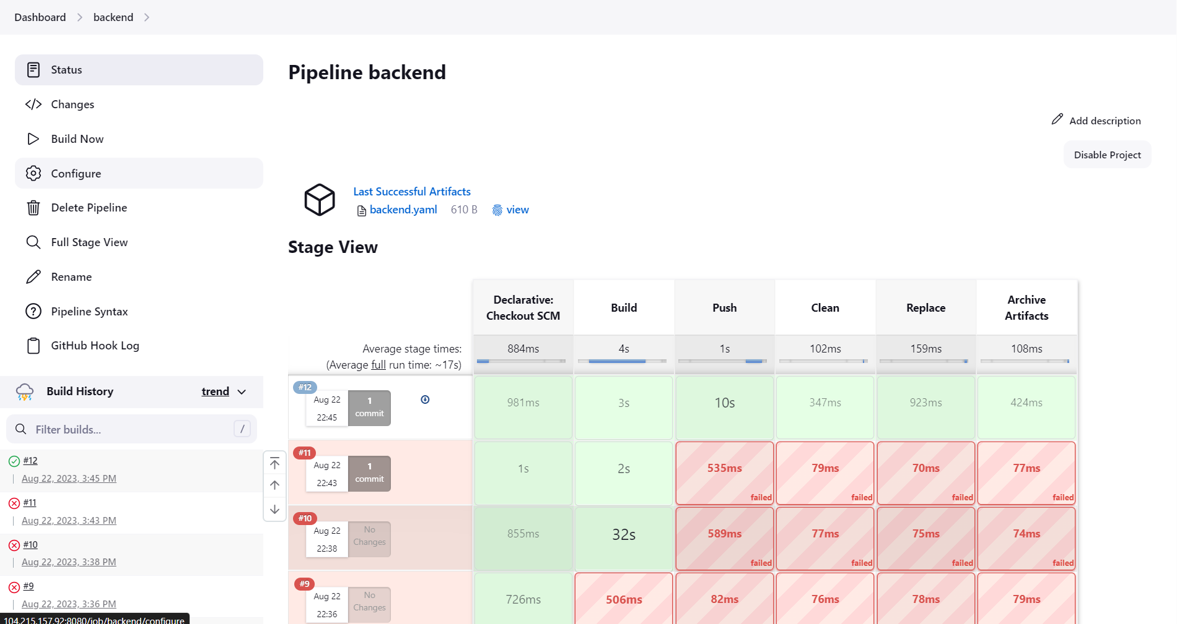

* Setup Azure Devops Pipeplines for frontend:

